

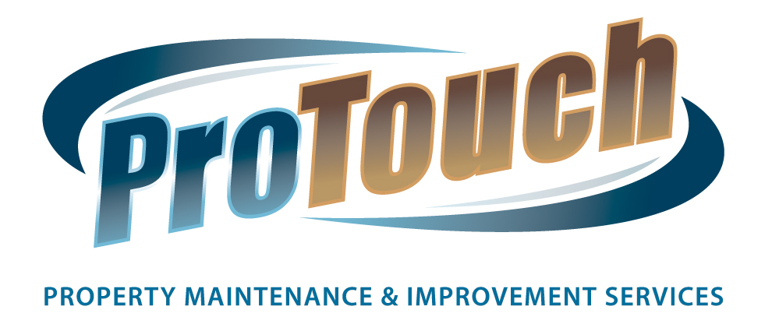

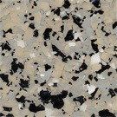

Dolphin

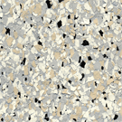
Granite

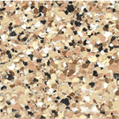
Desert Sand

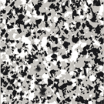
Smoke

Custom colors can be created upon request. Chip/Flake colors can be blended and matched to any
desired color. All products include a 10 year product and workmanship warranty.
Please allow a 2 day minimum for preparation/installation.

